Tasks
Medium:
I created my medium profile!
https://medium.com/@mohsinrasul80

Web Servers:
sudo systemctl start apache2
sudo systemctl status apache2
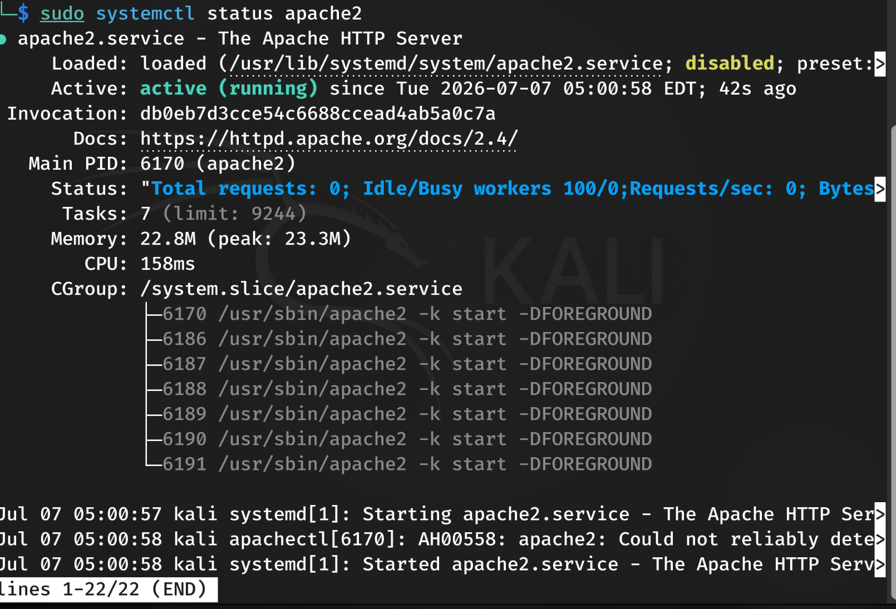
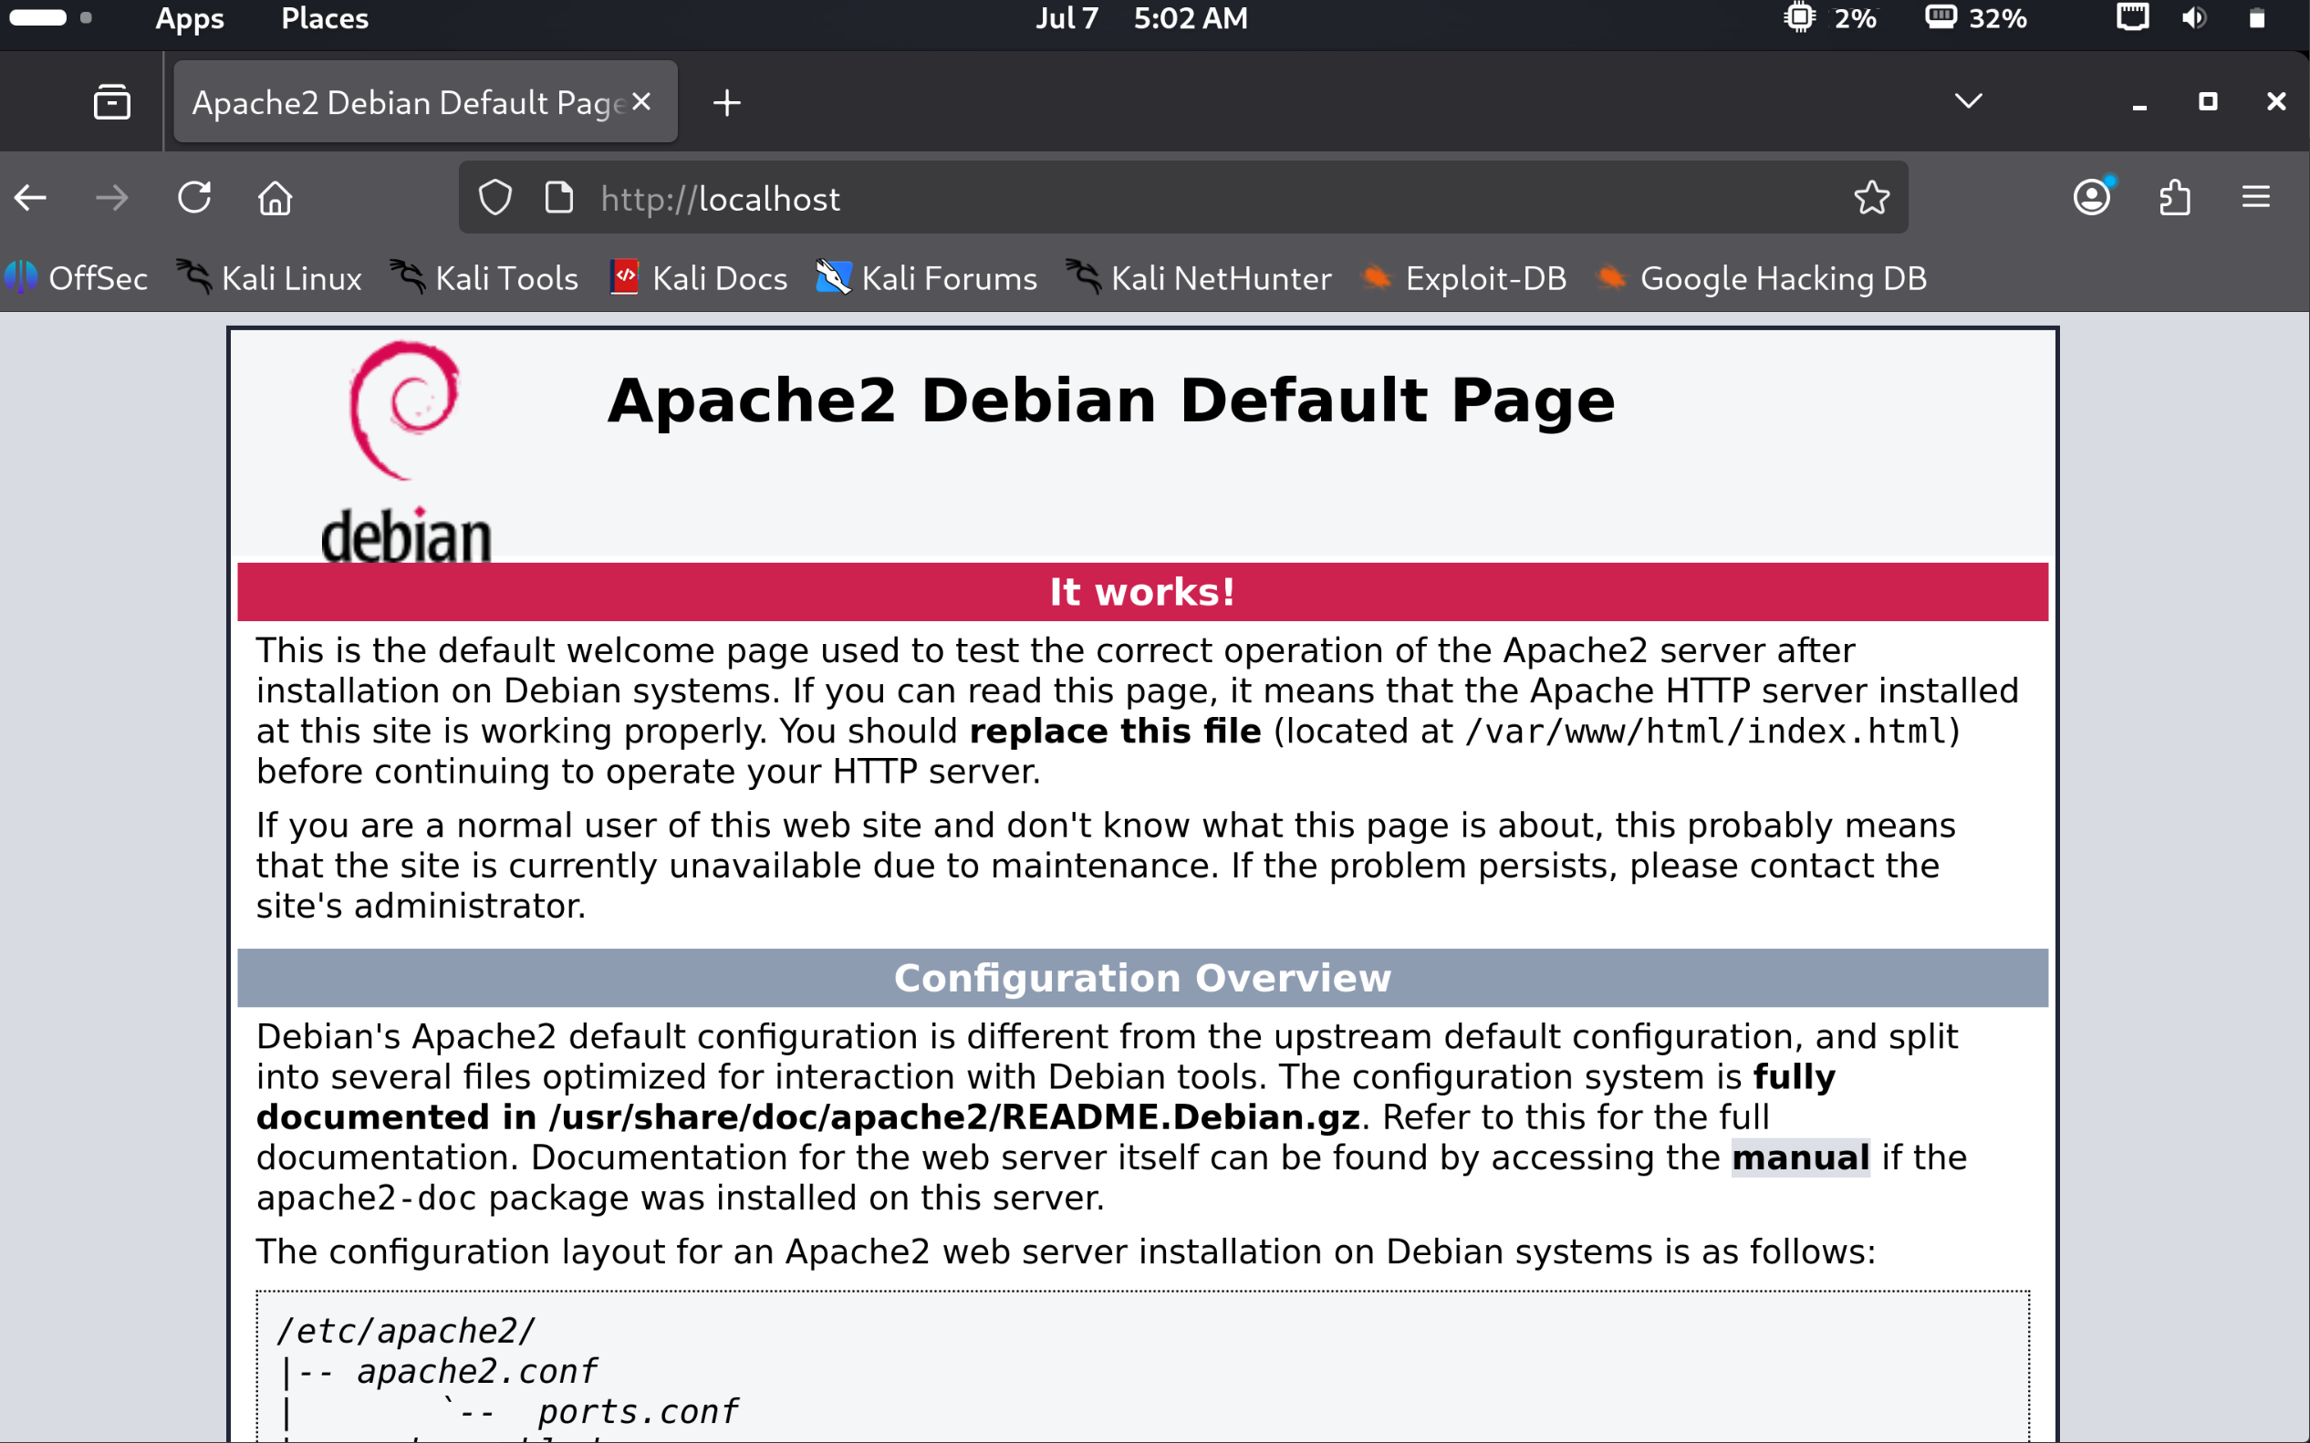

Docker:
sudo apt install docker.io -y
sudo systemctl restart docker
sudo systemctl status docker
sudo docker run hello-world (to test)
sudo docker ps (to verity which dockers running)

Directories:
ls -laR (to list and check files access level)
chmod 777 test.txt change the files access level
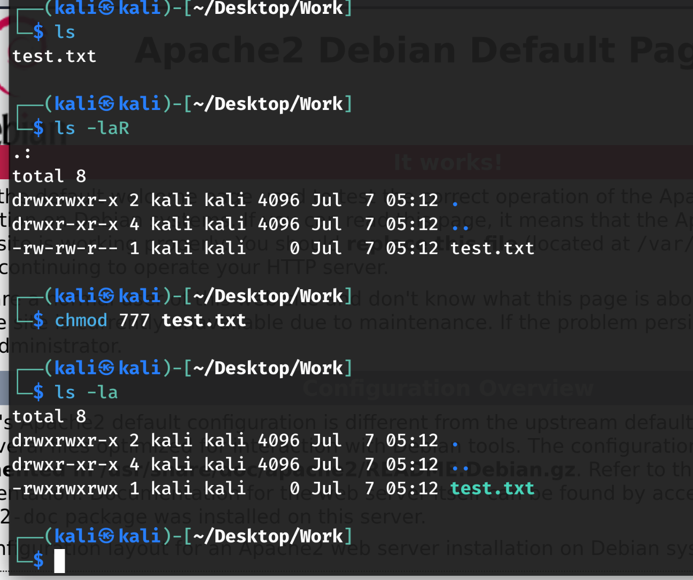
To give someone a permission, you just add the numbers together:
- Read + Write + Execute (4 + 2 + 1) = 7
- Read + Write (4 + 2 + 0) = 6
- Read Only (4 + 0 + 0) = 4

Git:
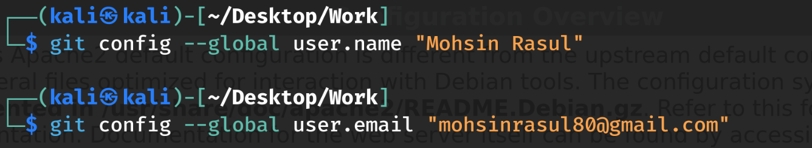
git init (to initialize an empty repo create inside the folder u want to create a repo in)
git add . (. to add all the files in the folder)
git commit -m “Your message” to commit that
then create a repo in your github
git remote add origin https://github.com/Mohsin-Rasul/NASTP.git
git push -u origin main
this will push to file to main branch

Creating a Web Server:
Created an index.html file and created a basic website!
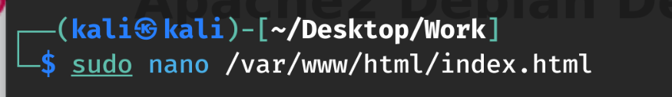
Then run it on localhost!
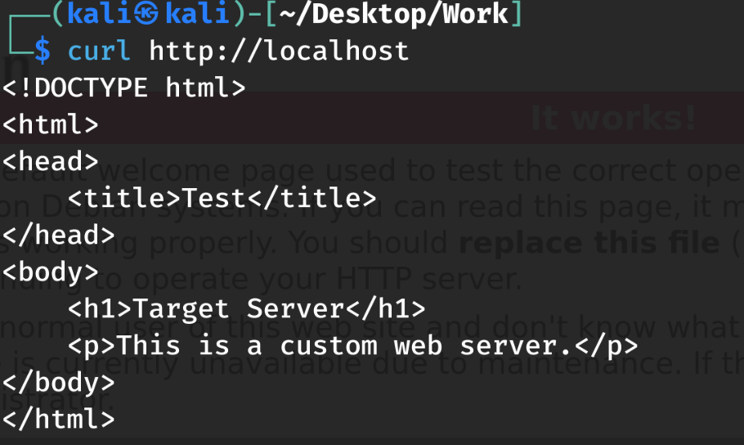
The Service Version Scan This will verify that the port is open and confirm exactly what software is hosting the custom site.
nmap -sV -p 80 localhost
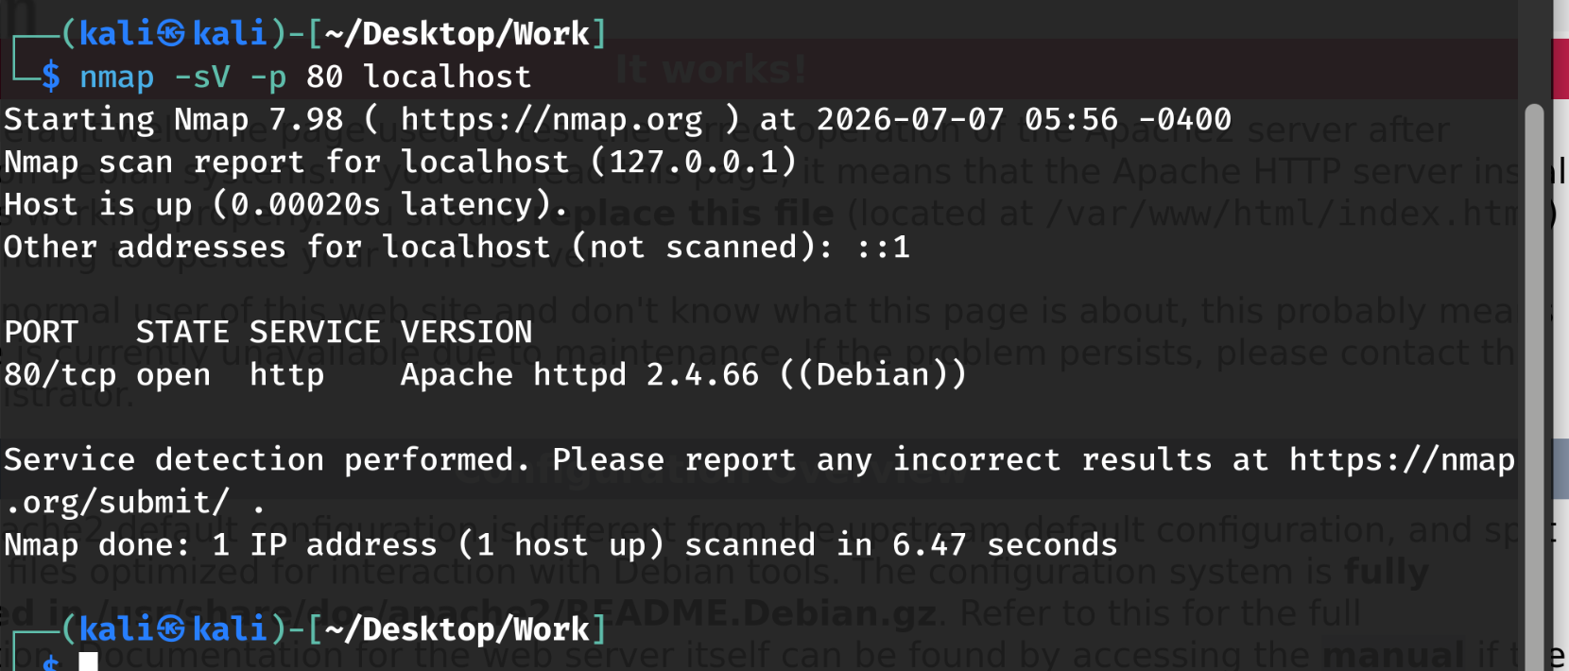
The HTTP Title Grabber is a NSE script to run. Instead of just looking at the port, this script actually pulls the HTML <title> tag from the website.
nmap --script http-title -p 80 localhost
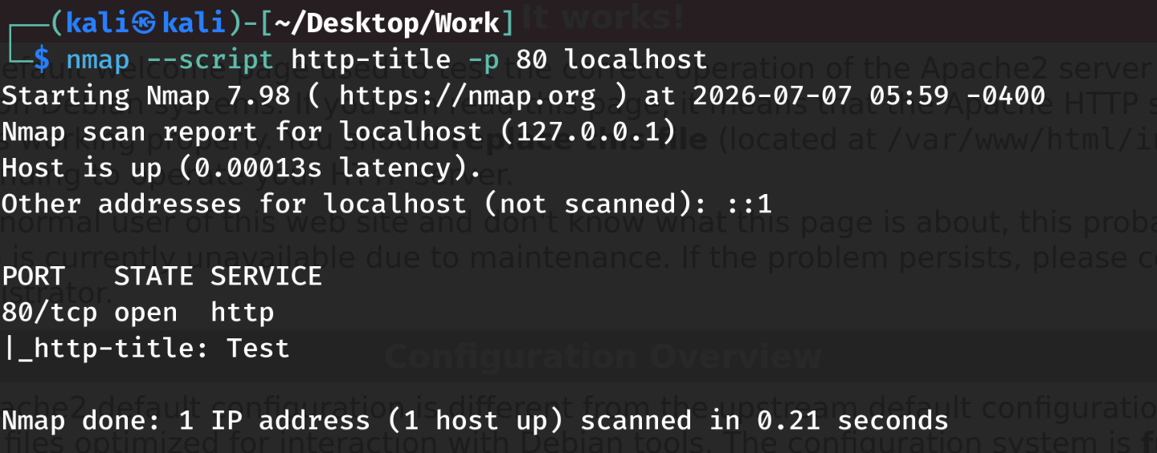
The Aggressive Scan does the full aggressive scan to pull everything at once, simulating a noisy attacker probing my custom setup.
nmap -A -p 80 localhost
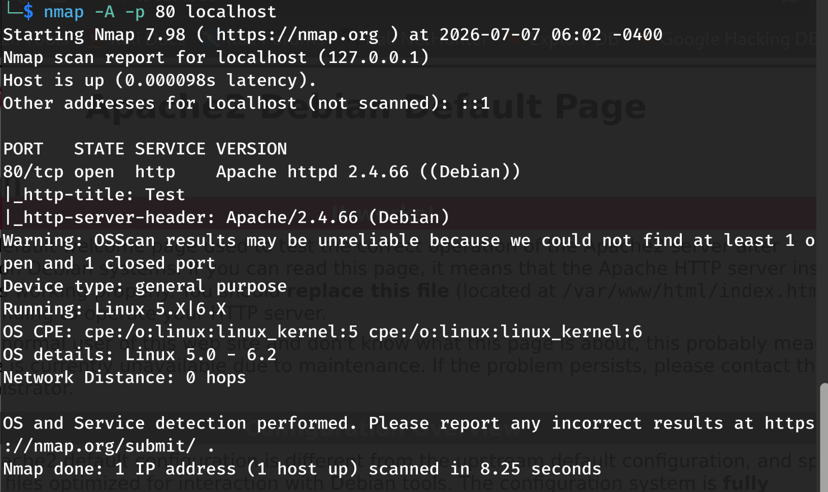

OS Scan
sudo nmap -O -p 80 localhost
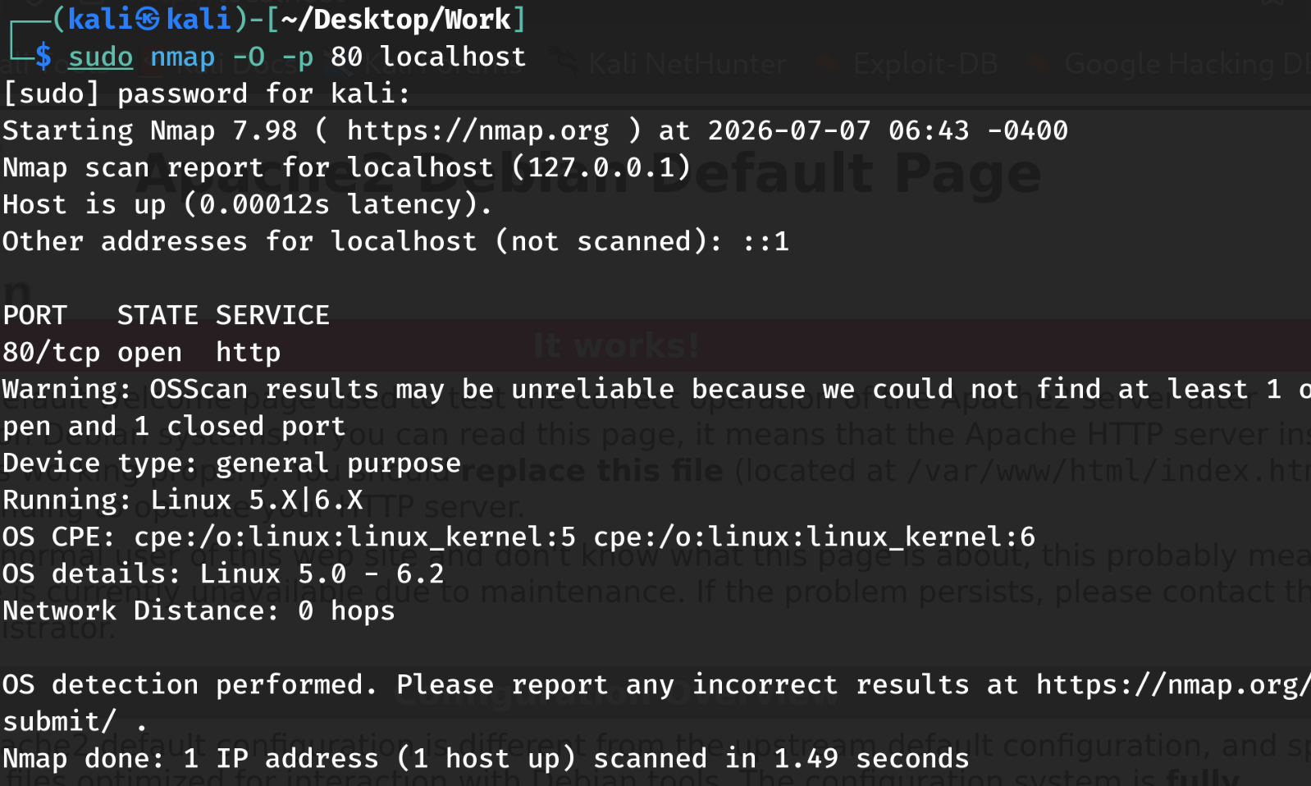
Scanning T4 (0 to 4 controls the speed)
nmap -T4 -p 80 localhost
